**Resource list for young people experiencing Domestic abusive relationships**

IDAS (Independent Domestic Abuse Services)

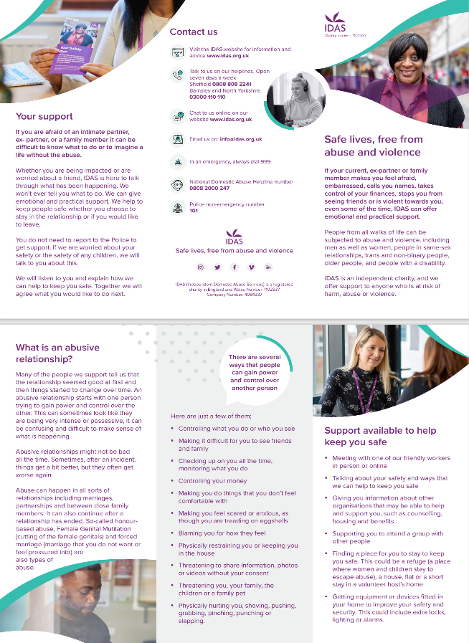

<https://idas.org.uk/wp-content/uploads/2023/11/IDAS_DA_Leaflet_23_07_23_web.pdf>

<https://idas.org.uk/wp-content/uploads/2023/11/My_Girlfriend_Checks_Messages_25_07_2023.pdf>

<https://idas.org.uk/wp-content/uploads/2022/02/Healthy-Relationships-Checklist-2.pdf>

The Mix is the UK’s leading support service for young people, to help you take on any challenge you’re facing - from mental health to money, from homelessness to finding a job, from break-ups to drugs. Support via online community, on social or counselling service

<https://www.themix.org.uk/apps-and-tools/is-my-relationship-healthy>

Online relationship quiz

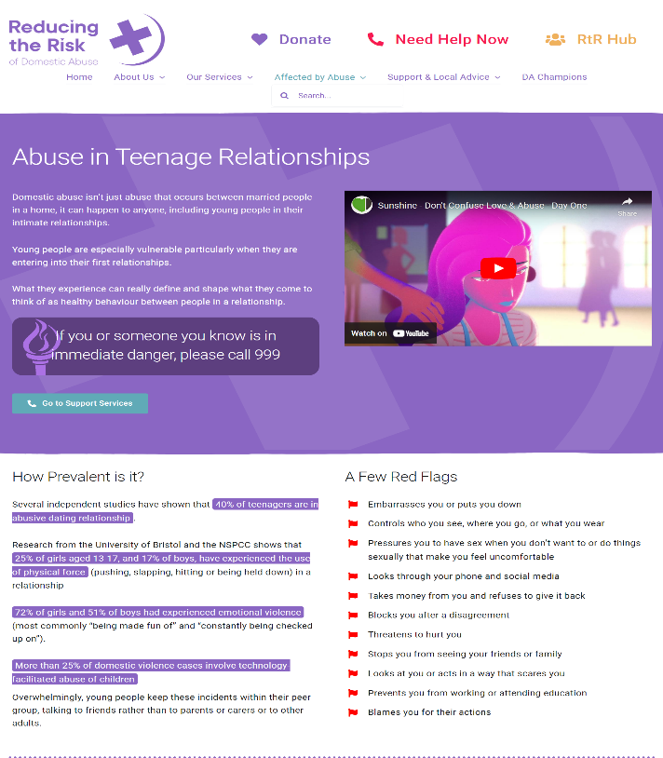

<https://reducingtherisk.org.uk/abuse-in-teenage-relationships/>

<https://www.nationaldahelpline.org.uk/>

<https://safelives.org.uk/resources-for-professionals/spotlights/spotlight-young-people-and-domestic-abuse/>

